**Suppose that continuous random variables X and Y have a joint probability density function given by:**

**fX,Y(x,y) = {c * (2-x^2)y, 0 <= x <= 1; 0 <= y <= 2**

**0, otherwise**

**Q) What value of c makes this a valid probability density function?**

**Q) Define the mode of a continuous random variable to be the point at which the density is maximized, if such a point exists.**

**What is the mode of Y?**

**Q) What is the expected value of XY, E[XY]?**

**Q) What is the covariance between X and Y, Cov[X,Y]?**

**Q) Are X and Y independent?**

**Your startup (Silicon Valley Spaghetti) is pioneering a new process for making pasta:**

* **The dough first goes through one of two cutting machines (called "Machine *A*" and "Machine *B*")**
* **Then, no matter the cutting machine it went through, the pasta goes through a stretching machine**
* **Dough starts in Machine *A* with probability 1/4 and in Machine *B* with probability 3/43/4. (Machine *B* is newer and faster, so the company puts more pasta through it.)**

**Let the initial length of the piece that is cut be stored in a random variable *X*.**

* **If the piece starts in machine *A*, *X* has a uniform distribution on [0,1].**
* **If the piece starts in machine *B*, *X* has a uniform distribution on [0,2].**

**After going through the cutting machines, the dough enters the stretching machine. The stretching machine stretches the dough into final length *Y*, which is uniformly distributed on [*X*,*X*+1].**

**Q) Draw two sketches:**

1. **A graph of the joint distribution of X and Y, conditional on machine A being selected.**
2. **A graph of the joint distribution of X and Y, conditional on machine B being selected.**

**You do not need to draw 3-dimensional plots. It is sufficient to draw the support of each joint distribution in the X-Y plane.**

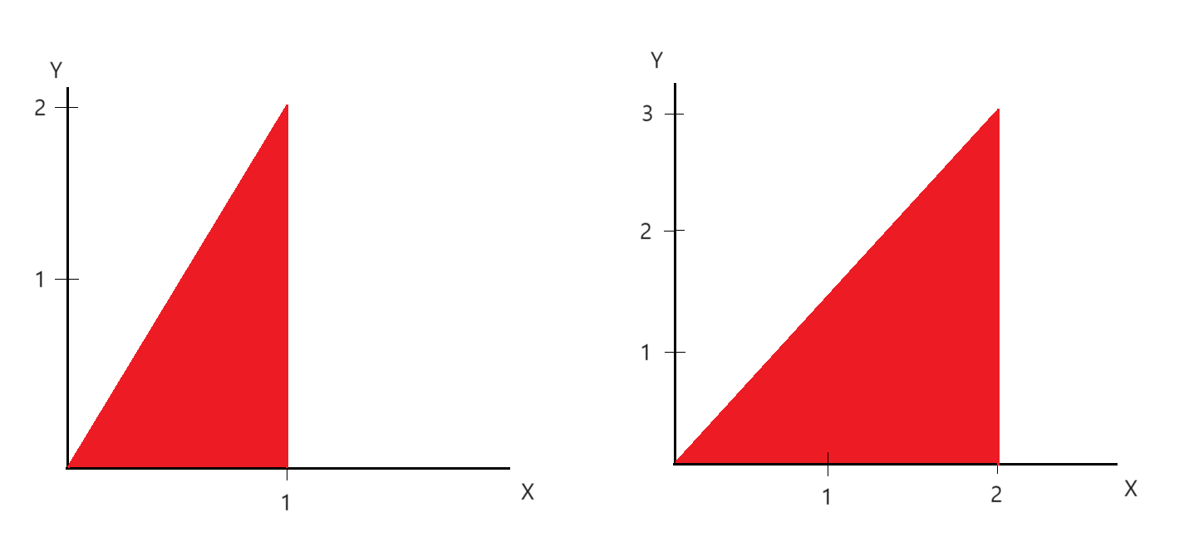

**Q) If the piece has final length less than 1, what is the conditional probability that it came from machine A?**

Derving from Bayes' rule, we know that (P(X|Y) * P(Y)) / P(Y) = (P(Y|X) * P(X)) / P(Y)

P(X|Y) = (P(Y|X) * P(X)) / P(Y)

So, here if we apply it, (P(A | Y < 1) * P(A)) / P(Y < 1).

And question is if the piece has final length less than 1, what is the conditional probability that it came from machine A.

We know from the drawn graph earlier, A should be in range of (0,2) and B is (0,3).

(P(A | Y < 1) * P(A)) = 1/2 * 1/4 = 1/8

P(Y < 1) from A and B given,

For A = 1/2 * 1/4 = 1/8

For B = 1/3 * 3/4 = 1/4

Now if we add both A and B cases, we get 3/8

Therefore if we divide 1/8 and 3/8, we get 1/3

**Let *A* and *B* be continuous random variables, both distributed uniformly on [−0.5,0.5]. Assume *A* and *B* are independent.**

**Define the sum, *S*=*A*+*B*, and the difference, *D*=*A*−*B*.**

**Q) Draw a picture of the A-B plane showing the square of support, with two regions labeled:**

**a. Points (*a*,*b*) for which *S*>1/2.**

**b. Points (*a*,*b*) for which *D*>1/2.**

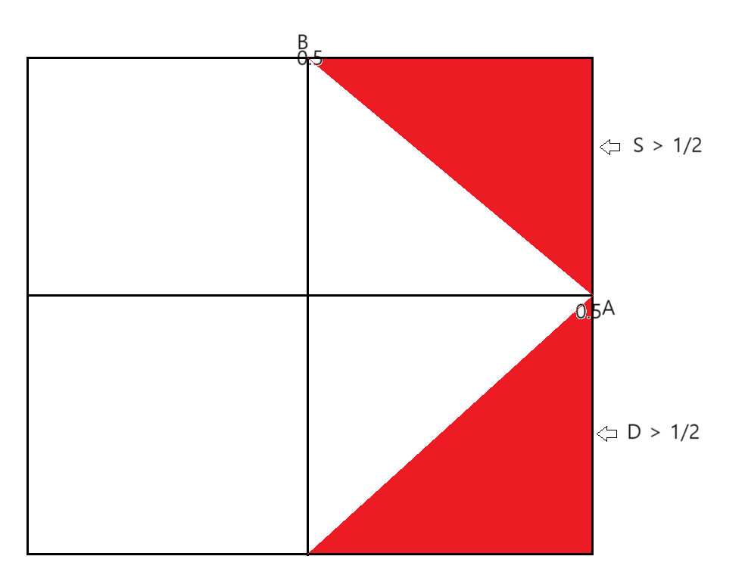

**Q) Compute *P*(*S*>1/2) (You may use geometrical arguments instead of integrating if you like)**

From the graph drawn earlier in 4.2, we know that by triangle shape colored in red in the rectangular framework, (0.5,0.5), it's 1/8. And since we need to know P(D > 1/2), only one triangle shape is correct here = 1/8

**Q) Are *S* and *D* correlated or uncorrelated? Prove your answer.**

So correlation is 0 meaning uncorrelated.

From one of the properties of covariance taught in the class:

Cov[X+Y, Z+W] = Cov[X,Z] + Cov[X,W] + Cov[Y,Z] + Cov[Y,W]

We can also apply it here:

Cov[A+B, A-B] = Cov[A,A] - Cov[A,B] + Cov[A,B] - Cov[B,B]

Cov[A+B, A-B] = Cov[A,A] - Cov[B,B]

Cov[A+B, A-B] = V(A) - V(B)

= 0

** When we do V(A) - V(B), since their range is same, they are 0

We know that the covariance is 0.

And from the definition 2.2.5, correlation is a rescaled derivative of covariance that capture the linear dependence between two random variables,

p[X,Y] = Cov[X,Y] / sigma[X]*sigma[Y]

If we plug Cov[S,D] which is 0, we can tell that correlation is 0 meaning they are uncorrelated.

**Q) Are *S* and *D* dependent or independent? Prove your answer.**

We know that by definition, if S and D are uncorrelated, they are independent.

Also the fact that their covariance is 0, it clearly tell us that they are independent.